The Possible Protective Effect of Ranolazine, Ivabradine and Trimetazidine on Experimentally Induced Diabetic Nephropathy in Rats
Abstract:
Background: The prevalence of diabetes has been increasing exponentially both in developing and developed nations. Diabetic nephropathy (DN) is the leading cause of end-stage renal disease (ESRD) across the world. Aim of the study: this work aimed to explore the potential efficacy of ranolazine, ivabradine and trimetazidine in prevention of development and progression of experimentally induced diabetic nephropathy in nicotinamide- streptozotocin (NA-STZ) type 2 diabetic rats’ model. Materials and Methods: 30 Rats were divided into: (Group I) normal control group, (Group II) non treated diabetic group received no treatment, (group III) ranolazine treated diabetic group received ranolazine (20 mg/kg twice daily), (Group IV) ivabradine treated diabetic group received ivabradine (10 mg/kg/day) and (Group V) trimetazidine treated diabetic group received trimetazidine (10 mg/kg/day). Results: ranolazine, ivabradine and trimetazidine induced significant decrease in fasting blood glucose, renal function parameters, renal MDA and renal iNOS in renal homogenate. Serum inflammatory marker (RBP) also significantly decreased together with genes of vascular damage (ET-1), significant down regulation of m RNA in Caspase-3 level and TGFB-1 was downregulated compared with diabetic non treated rats. Conclusion: Current findings confirmed ameliorative impact of ivabradine, trimetazidine and ranolazine on DN induced by NA-STZ T2DM. Ivabradine showed the best effect followed by trimetazidine. Ranolazine treated group had the lowest prophylactic effect.
Keywords: Diabetic Nephropathy; Ranolazine; Ivabradine; Trimetazidine; Gene Expression

Introduction
Diabetic nephropathy (DN) is the leading cause of end-stage renal disease (ESRD) across the world. Over recent years, contribution of renal tubular epithelial cells to the pathogenesis of DN have been recognized as they secrete excess amounts of inflammatory/fibrotic cytokines following their activation due to excessive accumulation of intracellular glucose and unrestrained stimulation of receptors for advanced glycation end-products (AGEs) that culminate in hyperactivity of nuclear factor kappa-light-chain-enhancer of activated B cells (NF-κB) signaling pathway, the master regulator of inflammation ^{[1].}
Ranolazine is a novel drug for angina that decreases frequency of angina attacks and recovers exercise tolerance in the affected patients. It is a selective inhibitor of cardiac late sodium channels that result in decreasing the intracellular Na+2 and Ca+2, leading to its anti-anginal properties in myocardial ischemia ^{[2].} Ranolazine has also been revealed to lower HbA1c in cardiac patients with comorbid diabetes. Furthermore, long-term ranolazine treatment shows preservation of β-cell and improvement of insulin secretion ^{[3].}
Ivabradine is proved to attenuate morbidity in angina and heart failure. The HR reducing effect of ivabradine is declared the principal mechanism of its therapeutic benefit ^{[4].} However, several of ivabradine's pleiotropic effects have recently emerged, which suggests the possibility of using ivabradine in yet unapproved indications such as endothelial dysfunction, hypertensive heart disease and hypertension with elevated or non-dipping HR ^{[5].}
Trimetazidine (TMZ), an anti-anginal agent, selectively inhibits the activity of mitochondrial long-chain 3-ketoacyl-CoA thiolase, resulting in inhibition of free fatty acid (FFA) oxidation and promotion of glucose oxidation ^{[6]}. In addition to metabolic effects, studies have indicated that TMZ exerts cardioprotective effects in diabetic individuals by reducing oxidative damage, inhibiting inflammation, apoptosis and improving endothelial function ^{[7].}
The aim of this study is exploring the potential efficacy of ranolazine, ivabradine and trimetazidine in prevention of development and progression of experimentally induced DN in NA-STZ type 2 diabetic rats’ model.

Materials and Methods
2.1 Chemicals and Kits:
Urea, albumin, nitric oxide, and creatinine kits were from Laboratory Bio-diagnostics Co., Cairo, Egypt. malondialdehyde (MDA) was obtained from Life Span Biosciences Company (LS. Bio), North America, USA. Rat retinol binding protein (RBP) ELISA kit MBS727758 was from MyBioSource, Inc. San Diego, CA, USA. While, Glucose kits was obtained from Roche diagnostic, Germany. Nicotinamide (NA) was obtained from Sisco research laboratory mass Ketan, India. RNA extraction and Reverse transcription kits were obtained from Thermo Fisher Scientific, Waltham, MA USA. Pharma Api, Company in India provided trimetazidine. Ranolazine, ivabradine, streptozotocin (STZ) and hematoxylin and eosin (H&E) staining solution were obtained by Sigma Aldrich (St. Louis, MO, USA). All chemicals used were of molecular grade.

2.2 Animals and Experimental Design:
Thirty adult male local strain rats (8-week-old weighing 180–200 g) were used for the current study. Animals were housed by adjusting room temperature at the Laboratory research of Pharmacology Department at Benha University and were handled manually for seven days to become totally adapted. The ethical rules for laboratory animal research were followed during all animal-related procedures based on the approval offered by Benha Faculty of Medicine (RC.8.10.2020 N 1017). Rats were divided into five equal groups where Standard deviation was assumed to be half the mean difference so 6 rats was used in every group. Group I (normal control group): rats were given saline and unrestricted permission to water and food to evaluate the normal basic parameters. Group II (Diabetic non treated group): rats were given saline and unrestricted permission to water and food with no medication for 8 weeks’ study after induction of nicotinamide- streptozotocin type 2 diabetes mellitus (NA-STZ T2DM) ^{[8].} Group III (ranolazine treated diabetic group): rats were medicated with ranolazine (20 mg/kg) twice daily orally ^{[9]} for 8 weeks study after induction of NA-STZ T2DM. Group IV (ivabradine treated diabetic group): rats were medicated with ivabradine (10 mg/kg/day) orally ^{[10]} for 8 weeks study after induction of NA-STZ T2DM. Group V (trimetazidine treated diabetic group): rats were medicated with trimetazidine (10 mg/kg/day) orally ^{[11]} for 8 weeks study after induction of NA-STZ T2DM. After being anesthetized for 2 to 5 min in a desiccator with a cotton pad soaked in diethyl ether, the rats were scarified and killed by cervical dislocation. Blood samples were taken by a heart puncture, then centrifuged for 10 min at 3000 rpm to separate the serum. Serum was maintained at (-20) ◦C for biochemical measurements while kidney tissue specimens were taken for homogenization, oxidative stress and inflammation measurements. Renal tissue specimens were preserved with Qiazol for RNA analysis and real-time PCR. Bowman’s solution was used for histology.
∼
−
−
−

2.3 Experimental Induction of NA-STZ T2DM:
In this study, experimental diabetes was induced by a single intraperitoneal (I.P) injection of STZ 60 mg/kg, freshly dissolved in cold citrate buffer, pH 4.5 after 15 min of I.P injection of NA120 mg/kg prepared in normal saline. Blood sample was obtained by pricking the lateral tail vein using a sterile needle by direct flow or by gently massaging ('milking') the tail and collecting the blood directly on a glucose test strip. Evaluate the animal’s general appearance and hemostasis before returning to the home cage. Hyperglycemia was confirmed by the elevated levels of random blood glucose were determined at 72 hours, then on day 7 after injection. Only rats confirmed to have NIDDM were used in the study. The animals with fasting blood glucose concentration more than 250mg/dl was used for the study ^{[12].}
2.4 Fasting Blood Glucose and Renal Function Parameters Assay:
Fasting blood glucose was measured using kits from Roche diagnostic, Germany, while the serum concentrations of urea, creatinine and urinary albumin excretion were measured using kits imported from Bio-diagnostic Company, Dokki, Giza, Egypt. These serum biochemicals were measured using BIO-RAD spectrophotometer following the instructions provided with each kit ^{[13,14],} in line with the manufacturer’s instructions.
2.5 Assessment of MDA and iNOS in kidney homogenate and Serum Retinol Binding Protein (RBP):
According to the instructions provided by the manufacturer, enzyme-linked immunosorbent assay (ELISA) kits (ab255730) used for measuring MDA concentrations were obtained from Life Span Biosciences Company (LS.Bio), North America for MDA and RBP Elisa kits catalogue number (MBS727758) was obtained from MyBioSource, Inc. San Diego, CA, USA. The colorimetric determination of NO using kits was imported from Bio-diagnostic Company, Dokki, Giza, Egypt. All of them were measured calorimetrically based on the protocols provided by the kits. Data from the ELISA reader was estimated and analyzed in accordance with the directions supplied with the kit.
To obtain the supernatant from the homogenate, tissue was precisely measured (0.1 g), homogenized (10% homogenate) and centrifuged (4000 rpm, 4 ◦C, 10 min) ^{[15].}

2.6 Quantitative Real Time PCR (qRT-PCR) of vascular damage (ET-1) in renal tissues:
RNA was extracted using a total RNA Purification Kit following the manufacturer protocol (Thermo Scientific, Fermentas, #K0731) from the kidney and was converted to cDNA using Reverse transcription kits (Thermo Scientific, Fermentas, #EP0451), Waltham, Massachusetts, USA, which was running using SYBR Green master mix (Thermo scientific, Waltham, MA, USA). Table 1 demonstrates the primers’ list used for gene amplification. Data was validated using the 2−∆∆Ct formula [16] in the 7500 Fast system Real time PCR (Applied Bio systems, Waltham, Massachusetts, USA). Gene expression and intensity changes were determined by comparative cycle threshold (CT) values, normalized to β-actin.
Table 1. Primers Oligonucleotide Sequences for q-PCR in renal rats.
Gene | Forward primer ( / 5 ------ / 3) | Reverse primer ( / 5 ------ / 3)
ET-1 | TCTCGGAGAGCAGAGACA CA | TGGACTTTGGAGTTTCTCCC T
B-actin | AAGTCCCTCACCCTCCCAAAAG | AAGCAATGCTGTCACCTTCCC

2.7 Quantitative Real Time PCR (qRT-PCR) of mRNA of caspase 3 and TGFβ-1 in renal tissues:
RNA was extracted using a total RNA Purification Kit following the manufacturer protocol (Thermo Scientific, Fermentas, #K0731). from the kidney and was converted to cDNA using Reverse transcription kits (Thermo Scientific, Fermentas, #EP0451), Waltham, Massachusetts, USA., which was run using SYBR Green master mix (Thermo scientific, Waltham, MA, USA). Table 2 demonstrates the primers’ list used for gene amplification. Data were validated using the 2−∆∆Ct formula [16] in the 7500 Fast system Real time PCR (Applied Bio systems, Waltham, Massachusetts, USA). Gene expression and intensity changes were determined by comparative cycle threshold (CT) values and normalized to β-actin.

Table 2. Primers Oligonucleotide Sequences for q-PCR in renal rats.
Gene | Forward primer ( / 5 ------ / 3) | Reverse primer ( / 5 ------ / 3)
Caspase3 | GGTATTGAGACAGACA GTGG | CATGGGATCTGTTTCTT TGC
TGFβ-1 | AAGAAGTCACCCGCGT GCTA | TGTGTGATGTCTTTGGT TTTGTCA
B-actin | AAGTCCCTCACCCTCCCAAAAG | AAGCAATGCTGTCACCTTCCC

2.8 Kidney Histology
Renal specimens were cut into slices, dehydrated, and embedded in paraffin for histological analysis. Slices were then cut into 3 µm thick to be stained with hematoxylin and eosin (H&E), then visualized under an optical microscope.

2.9 Data Analysis
The data was tabulated and evaluated using statistical package for social sciences (SPSS) program to analyze the results (version 26, IBM Analytics, New York, NY, USA). The data was expressed as means ± standard Error (SE). Employing the Shapiro-Wilk test with a normality level of p < 0.05, the data were examined for normality. To find variations between normally distributed data, the one-way analysis of variance (ANOVA) test was utilized. A significant ANOVA test was accompanied by post-hoc multiple comparisons utilizing Bonferroni testing to identify significant pairings. p < 0.05 was deemed significant in this study, and that was the accepted level of significance. Mann-Whitney U Test was used for data of non-normal distribution.

3. Results
3.1. Ameliorative impacts of ranolazine, ivabradine and trimetazidine on FBG and kidney function parameters:
In table (3), There were significant elevation of FBG, UAE, BUN and serum creatinine with a decrease in creatinine clearance in diabetic non treated rats compared with normal rats. While pretreatment with ranolazine, ivabradine and trimetazidine showed significant reduction in FBG, UAE, BUN with significant increasing in creatinine clearance if compared with diabetic non treated rats. The best results were seen in ivabradine treated diabetic rats.

Table 3. Prophylactic effect of ranolazine (20 mg/kg bid orally), ivabradine (10 mg/kg/day orally) and trimetazidine (10 mg/kg/day orally) for 8 weeks (wks) study after development of NA- STZ (110mg /kg I.P -65 mg /kg I.P) T2DM in DN on FBG and renal function parameters in rats (N=6) (Mean ± SEM):

Studied  groups  Parameters | Group (I): Normal control group | Group (II): Diabetic non treated group | Group (III): Ranolazine treated diabetic group | Group (IV): Ivabradine treated diabetic group | Group (V): Trimetazidine treated diabetic group
FBG (mg/dl) | 115.26 ^{d}± 6.11 | 339.43ª± 18.64 | 228.05^{b}± 11.72 | 152.52^{c}± 8.31 | 183.66^{bc}± 9.25
24h UAE (mg/ml/24h) | 0.35e± 0.01 | 1.86ª± 0.09 | 1.27^{b}±0.07 | 0.69^{d}±0.03 | 0.95^{c}±0.05
BUN (mg/dl) | 16.74e±0.79 | 75.13ª± 4.05 | 48.19^{b}± 2.36 | 27.22^{d}±1.82 | 34.48^{c}±2.00
S. creatinine (mg/dl) | 0.83^{d}± 0.05 | 2.27ª± 0.10 | 1.66^{b}± 0.08 | 1.21^{c}± 0.07 | 1.40^{bc}± 0.07
Cr. clearance (ml/min/100 g BW) | 1.76ª± 0.08 | 0.63^{d}±0.03 | 1.22^{c}± 0.06 | 1.47^{b}± 0.07 | 1.29^{bc}± 0.06

Values are means± SE for 6 different rats per treatment; values with different letters are statistically different at p < 0.05; SE, standard error.
- Superscript letters are arranged in descending manner where a indicates the highest value followed by b, c, d and finally e which indicates the lowest value.
- Superscript bc indicates that group V has no statistically significant difference with group III and IV but statistically significant difference with groups I and II.
3.2. Impacts of ranolazine, ivabradine and trimetazidine on serum retinol binding protein (RBP), renal MDA and renal iNOS in kidney homogenates’:
Figure 1 demonstrated a significant elevation in serum RBP levels, renal MDA and renal iNOS (A, B and C respectively) confirming tissue degradation in diabetic non-treated rats, while rats which received prophylactic therapy with ranolazine, ivabradine and trimetazidine showed significant reduction in serum RBP levels, renal MDA and renal iNOS levels when compared with diabetic non treated rats. The best improvement was seen in ivabradine treated group demonstrating that they had adapting ameliorative impact.
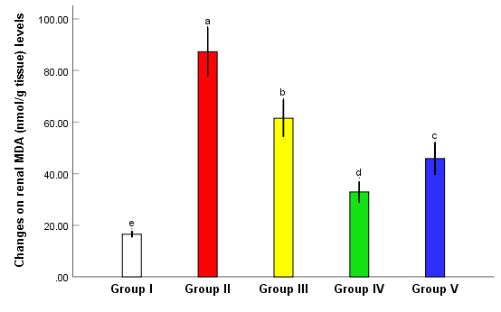
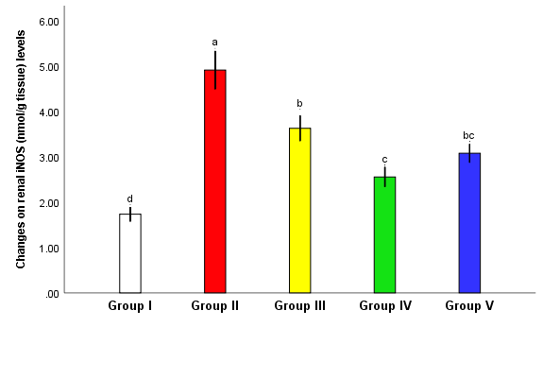

A

B
C

Group I: Normal control group, Group II: Diabetic non treated group, Group III: Ranolazine treated group. Group IV: Ivabradine treated group, Group V: Trimetazidine treated group.
Fig (1): Effect of prophylactic therapy with ranolazine (20 mg/kg twice daily orally), ivabradine (10 mg/kg/day orally) and trimetazidine (10 mg/kg/day orally) for 8 wks study after development of NA- STZ (110mg /kg I.P -65 mg /kg I.P) T2DM on serum RBP (A), renal MDA (B) and renal iNOS (C) in rats. Values are means ±SE for 6 different rats per treatment. Values are statistically different at p < 0.05.
- Superscript letters are arranged in descending manner where a indicates the highest value followed by b, c, d and finally e which indicates the lowest value.
- Superscript bc indicates that group V has no statistically significant difference with group III and IV but statistically significant difference with groups I and II.
3.3. Effects of ranolazine, ivabradine and trimetazidine on quantitative expression of ET-1 gene in renal tissue:
mRNA expression of ET-1 was upregulated in renal tissues of diabetic non treated group (figure 2) compared to normal rats. While pretreatment with ranolazine, ivabradine and trimetazidine showed significant down regulation of ET-1 expression. The best results were seen in ivabradine treated diabetic rats.
Group I: Normal control group, Group II: Diabetic non treated group, Group III: Ranolazine treated group. Group IV: Ivabradine treated group, Group V: Trimetazidine treated group.
Fig (2): Effect of prophylactic therapy with ranolazine (20 mg/kg twice daily orally), ivabradine (10 mg/kg/day orally) and trimetazidine (10 mg/kg/day orally) for 8 wks study after development of NA- STZ (110mg /kg I.P -65 mg /kg I.P) T2DM in experimentally induced DN on ET-1 relative expression in rats. Values are means ±SE for 6 different rats per treatment. Values are statistically different at p < 0.05.
- Superscript letters are arranged in descending manner where a indicates the highest value followed by b, c and finally d which indicates the lowest value.
- Superscript bc indicates that group V has no statistically significant difference with group III and IV but statistically significant difference with groups I and II.

3.4. Effects of Ranolazine, Ivabradine and Trimetazidine on Quantitative expression of caspase 3 and TGFB-1:
Caspase 3 and TGFB-1 mRNA expression was upregulated in renal tissues of diabetic non treated group (figure 3) A, B respectively compared to Normal rats. While pretreatment with Ranolazine, Ivabradine and Trimetazidine showed significant down regulation of Caspase 3 and TGFβ1 expression. The best results were seen in Ivabradine treated diabetic rats (Fig3) A, B.
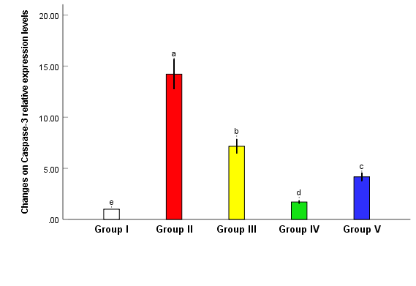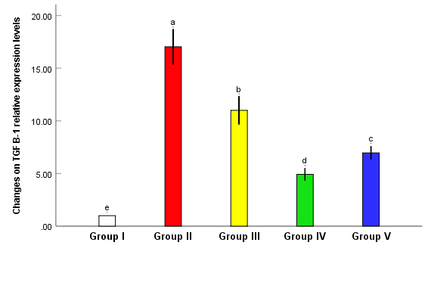
B
A

Group I: Normal control group, Group II: Diabetic non treated group, Group III: Ranolazine treated group. Group IV: Ivabradine treated group, Group V: Trimetazidine treated group.
Fig (3): Effect of prophylactic therapy with Ranolazine (20 mg/kg twice daily orally), Ivabradine (10 mg/kg/day orally) and Trimetazidine (10 mg/kg/day orally) for 8 wks study after development NA- STZ (110mg /kg I.P -65 mg /kg I.P) T2DM in experimentally induced DN on Caspase 3 mRNA (A) and TGFB-1 (B) relative expression in rats. Values are means ±SE for 6 different rats per treatment. Values are statistically different at p < 0.05.
- Superscript letters are arranged in descending manner where a indicates the highest value followed by b, c, d and finally e which indicates the lowest value.
- As no superscript letter in common, all groups are significantly different from each other (P<0.05).

3.5. Histopathological Examination:
The experimental groups’ renal histology was investigated in Figure 4. The control group’s kidney displayed normal renal structure, such as glomeruli and normal renal tubules (Figure 4A), while the rats in diabetic non treated group demonstrated a dilated Bowman’s capsule, shrinking glomeruli, and obvious tubular hydropic degeneration (Figure 4B). On the other hand, Groups with pretreatment using Ranolazine, Ivabradine and Trimetazidine showed improvement in renal histological structure (Figure 4C,D,E).

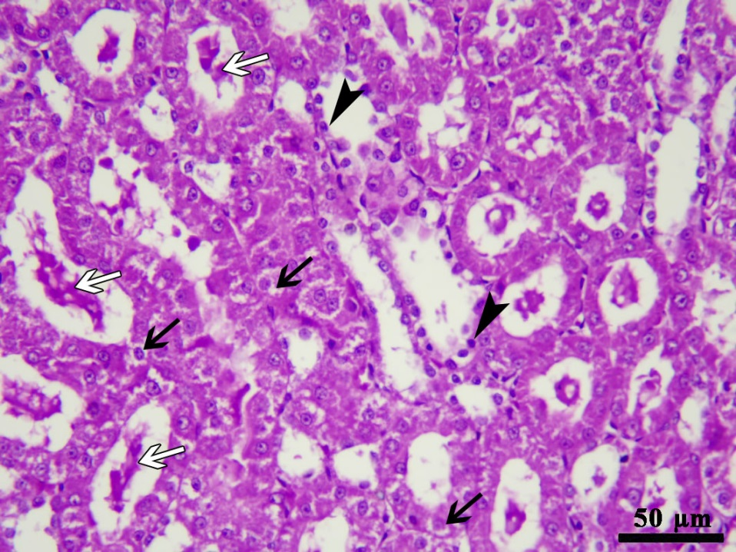
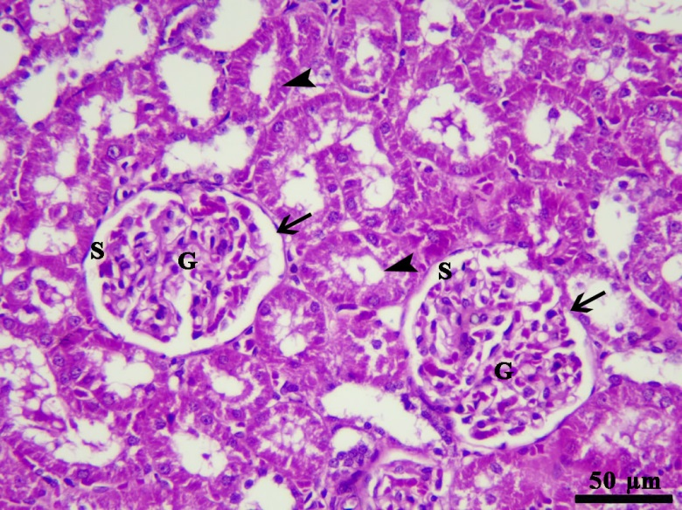
B
A

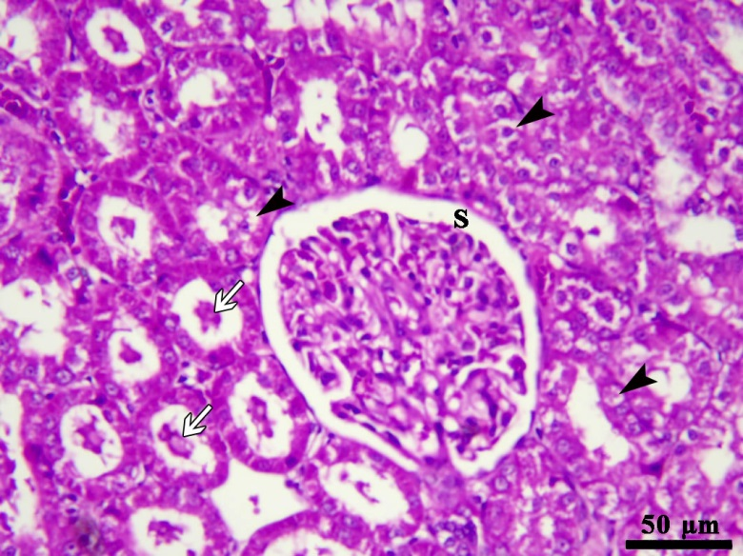
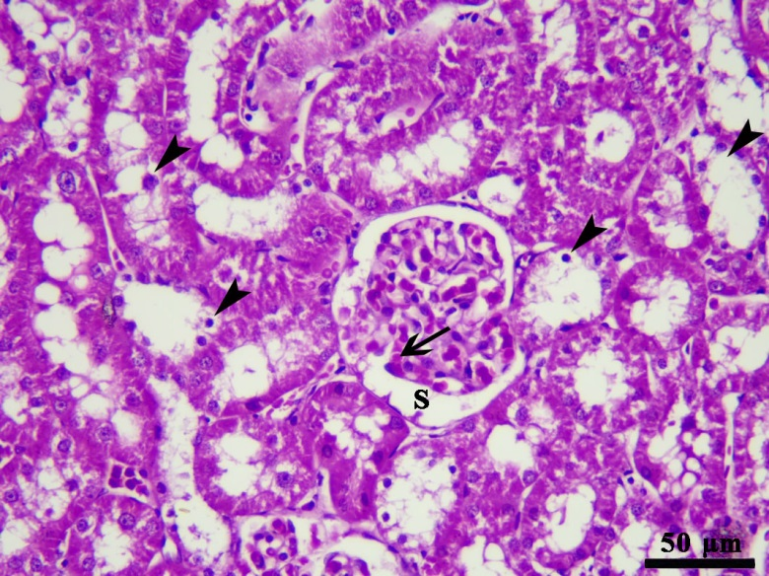

D
C

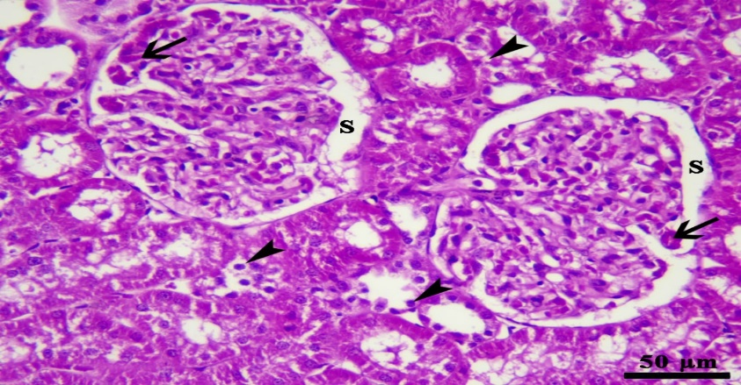
E

Figure 4. Impacts of prophylactic therapy with ranolazine (20 mg/kg twice daily orally), ivabradine (10 mg/kg/day orally) and trimetazidine (10 mg/kg/day orally) for 8 wks study after development NA- STZ (110mg /kg I.P -65 mg /kg I.P) T2DM in experimentally induced DN. (A): Normal control group, showed normal architecture of renal cortex; renal corpuscles (black arrows), normal glomeruli (G) and normal capsular space (S). (B): Diabetic non treated group showed hyaline cast in tubular lumen (white arrows), swelling and vacuolar degeneration of some tubular epithelial cells (black arrows) besides the nuclear pyknosis of some tubular epithelium (black arrow head). (C): Ranolazine treated diabetic group showed large renal corpuscle with mild dilatation of capsular space (S), vacuolar degeneration and nuclear pyknosis of some tubular epithelium (black arrow heads) besides presence of hyaline cast in the lumen of some renal tubules (white arrows). (D): Ivabradine treated diabetic group showed congestion of glomerular capillaries (black arrow), mild dilated capsular space (S), vacuolar degeneration and nuclear pyknosis of some tubular epithelium (black arrow heads). (E): Trimetazidine treated diabetic group showed congestion of glomerular capillaries (black arrows), mild dilatation of capsular space (S) besides the vacuolar degeneration and nuclear pyknosis of some tubular epithelium (black arrow heads). (H&E ×200), Scale bar = 50 µm.

4. Discussion:
The obtained data in the current work revealed that experimental induction of DN resulted in hyperglycemia determined at 72 h and was confirmed by the elevated glucose levels in plasma, then on day 7 after injection, rats with FBG level concentration more than 250 mg/dl were considered as diabetic and development of NA-STZ T2DM [8,12].
STZ is the most used diabetogenic chemical used to create experimental diabetes in animals. Nicotinamide opposes the effects of STZ, helps in partial destruction of beta cells and helps in the development of T2DM [17].
These experimentally induced diabetic untreated rats were allowed to develop DN for the next 4 weeks and showed significant increase in FBG level, 24h UAE, serum BUN level, serum creatinine level [8], and also these diabetic untreated rats showed significantly decrease in CR-CL [18]. Histopathological findings at 8th wks study also had demonstrated glomerulosclerosis, atrophy, tubular vacuolization, interstitial fibrosis, and thickening of GBM. These findings indicate that end-organ injuries had occurred in STZ- induced T2DM in non-treated rats used in the study [8]. While pre-administration of ranolazine, ivabradine and trimetazidine as monotherapy orally daily to diabetic rats just after development of NA-STZ T2DM for 8 weeks’ study resulted in significant decrease in FBG level, 24h UAE, serum urea level, serum creatinine level with significant increase in CR-CL level compared with diabetic non treated rats. The best improvement was seen in ivabradine treated diabetic rats.
This comes in agreement with Ning Y. et al., Dhalla et al. and Nayaka et al. who found that ranolazine monotherapy significantly reduced random blood glucose, which can be attributed to ranolazine inhibits glucagon secretion by blocking the Nav1.3 isoform of sodium channels in pancreatic α-cells, leading to glucagon and glucose lowering effects in animal models of diabetes [9,19 and 20].
Ranolazine (RN) improves ATP production and O2 consumption by stimulating glucose oxidation and decreasing fatty acid oxidation [21]. In type 2 diabetic patients, ranolazine has been shown to offer a variety of effects, including lowering blood glucose and glycosylated hemoglobin levels, promoting insulin release, and decreasing glucagon synthesis, therefore improving pre- and postprandial blood glucose [22].
We detected that ranolazine treated diabetic group (group III) showed improvement in urinary albumin excretion in agreement with Schmieder et al., and in contrast to Scheurle et al. who detected that GFR had remained stable while taking ranolazine and only worsened 6 weeks after ranolazine had been discontinued; therefore, ranolazine did not seem to have any impact on kidney function [23,24].
It was detected that treatment with ranolazine shows improvement in BUN compared to diabetic non treated group. Also, treatment with ranolazine showed decrease in s. creatinine compared to diabetic non treated group in concordance with Abbas et al. and Nayaka et al. but in contrast with Farsad et al. who reported that ranolazine did not affect creatinine level during 8 weeks post-treatment in diabetic angina patients. [25, 20 and 26].
These data suggest a novel and plausible mechanism for ranolazine’s putative antidiabetic properties, pointing to the renoprotective effect by significantly ameliorating diabetic nephropathy.
This was against results of Sandhiya et al. who reported no reduction in HbA1c and fasting blood glucose [27].
In this study It was found that ivabradine treated diabetic group showed fasting blood glucose improvement compared to diabetic non treated group agreeing with Kara et al. [28], but in contrast to Borer and Tardif who proved that ivabradine treatment was not associated with adverse effects on glucose metabolism [29]. Also, the best improvement was observed in group IV treated with ivabradine regarding BUN, urinary albumin and S. Creatinine. This agrees with Dogheim et al. who detected that the serum creatinine and blood urea nitrogen were reduced in Ivabradine treated patients compared to controls [30].
Trimetazidine treated diabetic group showed improvement in blood glucose level similarly as reported by Yang et al. [31].
An improvement in BUN was observed in group treated with trimetazidine which was better than that in ranolazine group agreeing with Amini et al. [32].
An improvement in s. creatinine was observed in group treated with trimetazidine which was better than that in ranolazine group agreeing with Abdelrahman et al. [33].
Retinol-binding protein 4 (RBP4) is a prominent adipokine in type 2 diabetes, although its effect on β-cell function remains elusive, and the underlying mechanisms are still unknown. It was found that elevated circulating RBP4 levels were inversely correlated with pancreatic β-cell function in diabetic mice across different glycemic stages [34]. RBP-4 serves as efficient biomarkers of tubular damage and thus could potentially be used as complementary measurements to the conventional approaches for diagnosis of DN in patients with type 2 diabetes [35].
In our study, diabetic non treated rats showed significant elevation of serum RBP4 level if compared with normal control rats, but pre-treatment of diabetic rats with ranolazine, Ivabradine and trimetazidine as monotherapy orally daily just after development of NA-STZ type 2 DM for 8 weeks’ study resulted in significant decrease in serum RBP level compared with diabetic non treated rats. Ivabradine treated diabetic rats showed the best improvement in this study. To the best of our knowledge this is the first study to evaluate the effect of ranolazine, ivabradine and trimetazidine on diabetics as regards retinol binding protein. Ivabradine treated group showed the best improvement in this study where RBP-4 serves as efficient biomarkers of tubular damage and thus could potentially be used as complementary measurement to the conventional approaches for diagnosis of DN in patients with type 2 diabetes [35]. So, this is suggestive for the better protective role of ivabradine against diabetic nephropathy.
An improvement in Retinol binding protein was observed in group V treated with trimetazidine which was significant.
Malondialdehyde (MDA) is widely used as a biomarker for assessing oxidative stress in biomedical fields. Lipid peroxidation is a chain phenomenon resulting in the formation of various active compounds that results in cellular damage [36].
In our study, diabetic non treated rats showed significant elevation of renal Malondialdehyde (MDA) level when compared with normal control rats, but pre-treatment of diabetic rats with ranolazine, ivabradine and trimetazidine as monotherapy orally daily just after development of NA-STZ T2DM for 8 weeks’ study resulted in significant decrease in serum MDA level compared with diabetic non treated rats.
MDA as an oxidative stress marker was found to be decreased in ranolazine treated rats in this work. This comes in agreement with Dogan et al. who reported that ranolazine treatment exhibited significant decrease (or improvement) of MDA in H9c2 cardiomyocytes study [37].
Insulin inhibits the production of reactive oxygen species and renal iNOS expression when the cells are exposed to pro-inflammatory agents [38]. In diabetic rats, insulin has been shown to protect against oxidative stress and inhibit apoptosis induced by H2O2 and intracellular ROS, and increase superoxide dismutase, catalase, and glutathione peroxidase activity [39]. ET receptors are located within the kidney, in glomerulus and renal tubules as well as in renal microcirculation, becoming of great importance in regulating kidney function [40].
In DN, iNOS expression level increases where The presence of iNOS is associated with tubular damage resulting in renal failure. The upregulation of NO in T2DM may explain the endothelial dysfunction that is associated with almost all diabetic complication. [41].
In our study, diabetic non treated rats showed significant elevation of renal iNOS as well as ET1 upregulation gene expression level if compared with normal control rats, but pre-treatment of diabetic rats with ranolazine, ivabradine and trimetazidine as monotherapy orally daily just after development of NA-STZ T2DM for 8 weeks’ study resulted in significant decrease in renal iNOS as well as ET1 downregulation of mRNA gene expression level compared with diabetic non treated rats.
Ivabradine treated group showed the best improvement in this study considering iNOS. Agreeing with our study, Li et al. found that in murine viral myocarditis, NO production in the plasma and heart was significantly increased in the ivabradine and myocarditis groups compared with the control group on days 7 and 14 [42].
Ranolazine reduced the pro-inflammatory reaction and improved learning and long-term memory in a Wistar rat model of T2DM. Its clinical use is especially interesting in patients with T2DM and coronary ischemia [43]. In Jordá et al., ranolazine enhanced the effects of insulin on AKT and eNOS, increasing the expression of p-AKT and p-eNOS, indicating that this effect is probably due to a facilitation of insulin action [44].
Ranolazine treated diabetic group showed significant decrease of ET1 level compared to non-treated diabetic group. As regards the endothelin-1, ivabradine treated group showed the best improvement in this study. however, Simko et al. were unable to demonstrate similar protective effects [45]. Also endothelin-1 in trimetazidine treated group showed moderate improvement in this study which was also observed in Fragasso et al. [46].
Apoptosis is a programmed cell death that has been repeatedly linked with diabetic kidney disease (DKD) [47]. In our study, diabetic non treated rats showed significant upregulation of mRNA gene expression Caspase-3 level if compared with normal control rats, but pre-treatment of diabetic rats with ranolazine, ivabradine and trimetazidine as monotherapy orally daily just after development of NA-STZ T2DM for 8 weeks’ study resulted in significant down regulation of m RNA in Caspase-3 level compared with diabetic non treated rats.
Agreeing with the protective role of trimetazidine, followed by ranolazine then ivabradine as Caspas-3 lowering agents reported in the current study Wen et al. reported that Caspase-3 inhibition ameliorated albuminuria, renal function, and tubulointerstitial fibrosis in diabetic mice [47] in contrast to Shahzad et al. who suggested that caspase-3-dependent cell death had a negligible effect [48].In the current study, ranolazine treated diabetic group showed slight downregulation of Caspase 3 expression compared to non-treated diabetic group in agreement with Ning et al. [9].
An explanation of this caspase-3 reducing effect of ranolazine was supported and explained by Chen et al. where cleavage of PARP and pro-caspase-3 in mice treated with doxorubicin is prevented by pre-treatment with ranolazine [49] also in agreement with Tocchetti et al. that reported the best Caspase-3 improvement was observed in diabetic group treated with Ivabradine [50].
TGFβ1 serves as one of the most important cytokines in the process of Epithelial –mesenchymal transition in kidney, also the key mediator of tissue fibrosis as it induces secretion of fibrillary collagens and promotes cell death and dedifferentiation [51]
In our study, diabetic non treated rats showed significant upregulation of TGFβ1 mRNA gene expression level if compared with normal control rats, but pre-treatment of diabetic rats with ranolazine, ivabradine and trimetazidine as monotherapy orally daily just after development of NA-STZ T2DM for 8 weeks’ study resulted in significant downregulation in TGFβ1 mRNA gene expression level compared with diabetic non treated rats. The best TGFβ1 improvement was observed in ivabradine treated diabetic group. Significant TGFβ1 improvement was observed in ranolazine and trimetazidine treated diabetic group. To the best of our knowledge this is the first study to evaluate the effect of ranolazine and ivabradine on diabetics as regards TGF-β1. This can be supported by Zhang, et al. where trimetazidine decreased the expression levels of TGF-β1, in the myocardial tissues of mice [52].

5. Conclusion:
Current findings confirmed ameliorative impact of ivabradine, trimetazidine and ranolazine on DN induced by NA-STZ T2DM. Ivabradine showed the best effect followed by trimetazidine. Ranolazine treated group had the lowest prophylactic effect. DN altered serum and kidney biomarkers, increased renal inflammatory markers, renal lipid peroxidation in renal homogenate with altered different gene expression at kidney tissue. The pre-administration of ivabradine, trimetazidine and ranolazine retrieved all altered markers at biochemical kidney level, downregulated the expression of genes linked with vascular damage, apoptosis and fibrosis. These results supported the potential use of ivabradine, trimetazidine and ranolazine to protect kidney against DN and open the field for further studies on diabetic complication models such as liver rather than kidney

Acknowledgments: The Pharmacology Department, Faculty of Medicine, Benha University, Egypt, provided technical and administrative assistance that was greatly appreciated by the authors throughout the course of this study.
References:
- Jigheh Z., Haghjo A., Argani H., Roshangar L., Rashtchizadeh N., Sanajou D., et al. Empagliflozin Attenuates Renal and Urinary Markers of Tubular Epithelial Cell Injury in Streptozotocin-induced Diabetic Rats. Ind J Clin Biochem 2020; 35(1):109–114.
- Salazar CA, Basilio Flores JE, Veramendi Espinoza LE, Mejia Dolores JW, Rey Rodriguez DE, and Loza Munárriz C. Ranolazine for stable angina pectoris. Cochrane Database Syst Rev 2017.8;2(2):CD011747.
- Elkholy S., Tawfik M. and Mohammed A. The Possible antidiabetic effects of ranolazine versus gliclazide in hfd/stz-induced type 2 diabetes in male albino rats. Medicine Updates (2020; 1(1): 9-28.
- Borer JS, Swedberg K, Komajda M, Ford I, Tavazzi L, Böhm M, et al. Efficacy Profile of Ivabradine in Patients with Heart Failure plus Angina Pectoris. Cardiology 2017;136(2):138-144.
- Baka T. and Simko F. Ivabradine reversed nondipping heart rate in rats with l-NAME-induced hypertension. Clinical and experimental pharmacology & physiology 2019; 46(6): 607–610.
- Chrusciel P, Rysz J, and Banach M. Defining the role of trimetazidine in the treatment of cardiovascular disorders: some insights on its role in heart failure and peripheral artery disease. Drugs 2014;74(9):971-80.
- Zhao Y., Li S., Quan E., Zhang H., Wu Y., Luo Y., et al. Trimetazidine inhibits cardiac fibrosis by reducing reactive oxygen species and downregulating connective tissue growth factor in streptozotocin-induced diabetic rats. Experimental and Therapeutic Medicine 2019; 18: 1477-1485.
- Sharma A., Kanawat D., Mishra A., Dhakad P., Sharma P., Srivastava V., et al. Dual therapy of vildagliptin and telmisartan on diabetic nephropathy in experimentally induced type 2 diabetes mellitus rats. Journal of the Renin-Angiotensin-Aldosterone System 2014; 410–418.
- Ning Y., Zhen W., Fu Z., Jiang J., Liu D., Belardinelli L., et al. Ranolazine increases β-cell survival and improves glucose homeostasis in low-dose streptozotocin-induced diabetes in mice. The Journal of pharmacology and experimental therapeutics 2011; 337(1): 50–58.
- Simko F, and Baka T. Ivabradine and Blood Pressure Reduction: Underlying Pleiotropic Mechanisms and Clinical Implications. Front Cardiovasc Med 2021.;10;8:607998.
- Ramezani-Aliakbari F., Badavi M., Dianat M., Mard S. and Ahangarpour A. The Effects of Trimetazidine on QT-interval Prolongation and Cardiac Hypertrophy in Diabetic Rats. Arquivos Brasileiros de Cardiologia 2019; 112(2): 173-178.
- Maheshwari RA, Balaraman R, Sen AK and Seth A K. Effect of coenzyme Q10 alone and its combination with metformin on streptozotocin-nicotinamide-induced diabetic nephropathy in rats. Research Article. Indian J Pharmacol Pharm Sci 2014. 46 (6):627-632.
- Gnanaraj, C., Shah, M.D., Song, T.T., and Iqbal, M. Hepatoprotective mechanism of Lygodium microphyllum (Cav.) R. Br. Through ultrastructural signaling prevention against carbon tetrachloride (CCl4)-mediated oxidative stress. Biomed. Pharmacother 2017., 92,1010–1022.
- Li, X.-X, Jiang, Z.-H, Zhou, B, Chen, C, and Zhang, X.-Y. Hepatoprotective effect of gastrodin against alcohol-induced liver injury in mice. J. Physiol. Biochem 2019., 75, 29–37.
- Zhao, X.; Zhang, J.; Yi, S.; Li, X.; Guo, Z.; Zhou, X. et al. Lactobacillus plantarum CQPC02 prevents obesity in mice through the PPAR-α signaling pathway. Biomolecules 2019, 9, 407.
- Pfaffl, M.W. A new mathematical model for relative quantification in real-time RT–PCR. Nucleic Acids Res 2001. 29, e45.
- Ghasemi A and Jeddi S. Streptozotocin as a tool for induction of rat models of diabetes: a practical guide. EXCLI J. 2023 Feb 21; 22:274-294.
- Liu SC, Tu YK, Chien MN, and Chien KL. Effect of antidiabetic agents added to metformin on glycaemic control, hypoglycaemia and weight change in patients with type 2 diabetes: a network meta-analysis. Diabetes Obes Metab 2012;14(9):810-20.
- Dhalla AK, Yang M, Ning Y, Kahlig KM, Krause M, Rajamani S, et al. Blockade of Na+ channels in pancreatic α-cells has antidiabetic effects. Diabetes 2014.;63(10):3545–56.
- Nayaka R, and Vaish R. Renoprotective Potential of Ranolazine in Ameliorating Diabetic Nephropathy in A Rat Model of Streptozotocin-Induced Diabetes. J Pharm Negat Results 2022;1599–605.
- McCormack JG, Barr RL, Wolff AA, and Lopaschuk GD. Ranolazine stimulates glucose oxidation in normoxic, ischemic, and reperfused ischemic rat hearts. Circulation 1996; 93(1):135–42.
- Zeng X, Zhang Y, Lin J, Zheng H, Peng J, and Huang W. Efficacy and safety of ranolazine in diabetic patients: a systematic review and meta-analysis. Ann Pharmacother 2018.; 52(5):415–24.
- Schmieder RE, Bramlage P, Haller H, Ruilope LM, and Böhm M. The Effect of Resting Heart Rate on the New Onset of Microalbuminuria in Patients With Type 2 Diabetes: A Subanalysis of the ROADMAP Study. Medicine (Baltimore) 2016.;95(15):e3122.
- Scheurle C, Dämmrich M, Becker JU, and Baumgärtel MW. Renal phospholipidosis possibly induced by ranolazine. Clin Kidney J 2014.;7(1):62–4.
- Abbas LM, Al-Mudhafar RH, Al-Mudhafar DH, and Hadi NR. Ranolazine protects the kidney from ischemia/reperfusion injury in adult male rats by modulation of inflammatory and oxidative pathways and suppression of Notch2/Hes1 signaling pathway. Sys Rev Pharm 2021.;12:494–504.
- Farsad BF, Alavi SM, Ghorbanian G, Fahimi F, Ghaemmaghami Z, Mehr AZ, et al. The therapeutic efficnecy of ranolazine in comparison with conventional therapy in diabetic individuals with ischemic heart disease; a randomized clinical trial. J Ren Inj Prev 2019.;9(1):e04–e04.
- Sandhiya S, Dkhar SA, Pillai AA, George M, Jayaraman B, and Chandrasekaran A. Comparison of ranolazine and trimetazidine on glycemic status in diabetic patients with coronary artery disease–A randomized controlled trial. J Clin diagnostic Res JCDR 2015;9(1):OC01.
- Kara Z, Güven B, Besikci AO, Yıldırım N, and Altunay H. Pleiotropic vascular effects of ivabradine in streptozotocin-induced diabetes. Eur J Pharmacol 2022.;916:174551.
- Borer JS, and Tardif JC. Efficacy of ivabradine, a selective I(f) inhibitor, in patients with chronic stable angina pectoris and diabetes mellitus. Am J Cardiol 2010.;105(1):29–35.
- Dogheim GM, Khairat I, Omran GA, El-Haggar SM, Amrawy AM El, and Werida RH. Clinical comparative study assessing the effect of ivabradine on neopterin and NT-Pro BNP against standard treatment in chronic heart failure patients. Eur J Clin Pharmacol 2022.; 78(6):943–54.
- Yang Y, Wang Y, He Z, Liu Y, Chen C, Wang Y, et al. Trimetazidine inhibits renal tubular epithelial cells to mesenchymal transition in diabetic rats via upregulation of Sirt1. Front Pharmacol 2020.;11:1136.
- Amini N, Sarkaki A, Dianat M, Mard SA, Ahangarpour A, and Badavi M. The renoprotective effects of naringin and trimetazidine on renal ischemia/reperfusion injury in rats through inhibition of apoptosis and downregulation of micoRNA-10a. Biomed Pharmacother 2019;112:108568.
- Abdelrahman RS, Abdelsalam RA, and Zaghloul MS. Beneficial effect of trimetazidine on folic acid‐induced acute kidney injury in mice: Role of HIF‐1α/HO‐1. J Biochem Mol Toxicol 2022 ;36(5):e23011.
- Huang R, Bai X, Li X, Wang X, and Zhao L. Retinol-binding protein 4 activates STRA6, provoking pancreatic β-cell dysfunction in type 2 diabetes. Diabetes 2021.;70(2):449–63.
- Abbasi F, Moosaie F, Khaloo P, Firouzabadi FD, Abhari SMF, Atainia B, et al. Neutrophil gelatinase-associated lipocalin and retinol-binding protein-4 as biomarkers for diabetic kidney disease. Kidney Blood Press Res 2020.;45(2):222–32.
- Singh Z, Karthigesu IP, Singh P, and Rupinder K. Use of malondialdehyde as a biomarker for assessing oxidative stress in different disease pathologies: a review. Iran J Public Health 2014.;43(Supple 3):7–16.
- Dogan Z, Durmus S, Ergun DD, Gelisgen R, and Uzun H. Ranolazine exhibits anti-inflammatory and antioxidant activities in H9c2 cardiomyocytes. Eur Rev Med Pharmacol Sci 2023.;27(7).
- Brabazon F, Bermudez S, Shaughness M, Khayrullina G, and Byrnes KR. The effects of insulin on the inflammatory activity of BV2 microglia. PLoS One 2018.;13(8):e0201878.
- Song Y, Ding W, Bei Y, Xiao Y, Tong HD, Wang LB, et al. Insulin is a potential antioxidant for diabetes-associated cognitive decline via regulating Nrf2 dependent antioxidant enzymes. Biomed Pharmacother 2018.;104:474–84.
- Anguiano L, Riera M, Pascual J, and Soler MJ. Endothelin blockade in diabetic kidney disease. J Clin Med 2015.;4(6):1171–92.
- Aly, M.I., Abdalla, M.N., El Akad, M.H. et al. Role of iNOS and eNOS expression in a group of Egyptian diabetic and nondiabetic nephropathy patients. Egypt J Intern Med2013: 25, 33–36.
- Li YC, Luo Q, Ge LS, Chen YH, Zhou ND, Zhang T, et al. Ivabradine inhibits the production of proinflammatory cytokines and inducible nitric oxide synthase in acute coxsackievirus B3-induced myocarditis. Biochem Biophys Res Commun 2013.;431(3):450–5.
- Gilbert BW, Sherard M, Little L, Branstetter J, Meister A, and Huffman J. Antihyperglycemic and metabolic effects of ranolazine in patients with diabetes mellitus. Am J Cardiol 2018.;121(4):509–12.
- Jordá A, Aldasoro M, Campo-Palacio I, Vila JM, Aldasoro C, Campos-Campos J, et al. Facilitation of Insulin Effects by Ranolazine in Astrocytes in Primary Culture. Int J Mol Sci 2022.;23(19).
- Simko F, Baka T, Stanko P, Repova K, Krajcirovicova K, Aziriova S, et al. Sacubitril/Valsartan and Ivabradine Attenuate Left Ventricular Remodelling and Dysfunction in Spontaneously Hypertensive Rats: Different Interactions with the Renin–Angiotensin–Aldosterone System. Biomedicines 2022.;10(8):1844.
- Fragasso G, Piatti PM, Monti L, Palloshi A, Setola E, Puccetti P, et al. Short-and long-term beneficial effects of trimetazidine in patients with diabetes and ischemic cardiomyopathy. Am Heart J 2003.;146(5):854.
- Wen S, Wang ZH, Zhang CX, Yang Y, and Fan QL. Caspase-3 promotes diabetic kidney disease through gasdermin E-mediated progression to secondary necrosis during apoptosis. Diabetes, Metab Syndr Obes targets Ther 2020.;13:313.
- Shahzad K, Bock F, Gadi I, Kohli S, Nazir S, Ghosh S, et al. Caspase-1, but not caspase-3, promotes diabetic nephropathy. J Am Soc Nephrol 2016.;27(8):2270–5.
- Tocchetti CG, Carpi A, Coppola C, Quintavalle C, Rea D, Campesan M, et al. Ranolazine protects from doxorubicin‐induced oxidative stress and cardiac dysfunction. Eur J Heart Fail 2014 ;16(4):358–66.
- Chen SL, Hu ZY, Zuo GF, Li MH, and Li B. I. (f) current channel inhibitor (ivabradine) deserves cardioprotective effect via down-regulating the expression of matrix metalloproteinase (MMP)-2 and attenuating apoptosis in diabetic mice. BMC Cardiovasc Disord 2014;14:1–10.
- Kang HM, Ahn SH, Choi P, Ko YA, Han SH, Chinga F, et al. Defective fatty acid oxidation in renal tubular epithelial cells has a key role in kidney fibrosis development. Nat Med 2015.;21(1):37-46.
- Zhang J, He X, Bai X, Sun Y, Jiang P, Wang X, et al. Protective effect of trimetazidine in radiation-induced cardiac fibrosis in mice. J Radiat Res 2020;61(5):657–65.

